For immediate release:

HKTDC Hong Kong Toys & Games Fair is Set to Return in January 2020
Unveiling the Latest Global Market Trend
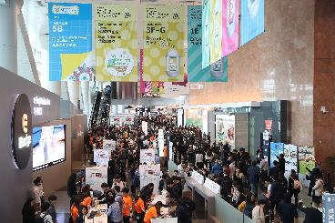 | 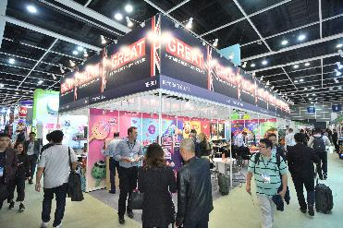 | 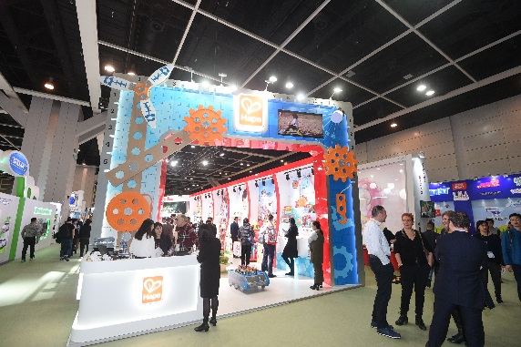
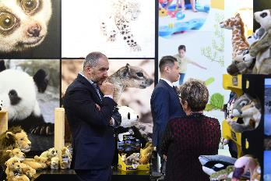 | 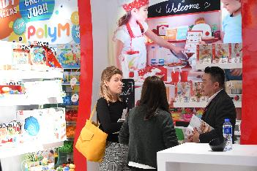 | 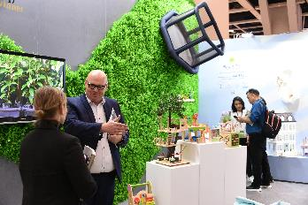

Photo download

1 November 2019 – The 46th HKTDC Hong Kong Toys & Games Fair is set to be held from 6-9 January 2020. The fair is Asia’s largest event of its kind and is expecting more than 2,000 global exhibitors to showcase a wide variety of products ranging from traditional toys to high-tech games, from famed names to emerging brands.

Tech and STREAM toys in demand
The integration of technology in toys is the industry’s dominant trend. Digitalisation continues to make inroads into all areas, also bringing inspiration to traditional toys such as soft toys, board games, puzzles, etc. The Fair’s Smart Tech Toys zone brings together a vast array of tech-based toys and games including those operated via mobile apps, or incorporated with the latest VR, AR and MR technologies. Parents increasingly emphasise children’s development and realise the importance of learning through play. The STREAM Toys Product Display will continue to highlight educational and high-tech toys featuring science, technology, robotics, engineering, arts and mathematics (STREAM).

Hong Kong company, Fame Master Enterprise Limited, who is famous for its high-quality 4D puzzle, is bringing their signature collection of Brick Man funny anatomy figure. The figure is 300mm tall and consists of 36 pieces of parts. With attention to every detail including Brick Man’s internal organs and skeletal bones, it provides a fun way to learn about the human body.

Art & Smart Egg Kft from Hungary will present an award-winning 3D labyrinth game, Smart Egg, that is not only a puzzle but also provides a fun and challenging way to keep the brain and hand active. Each Smart Egg is designed with a different puzzle and offers a large variety of different levels for anyone aged 6 to 99!

Premium brands on display
The signature Brand Name Gallery is expecting around 250 brands this year including 4M, B. Duck, Eastcolight, HAPE, Intex, Kintoy, Rastar and WELLY, offering products of excellence in design and assured quality. An exhibitor of the Brand Name Gallery, Welly Die Casting International Limited will showcase a 1:24 Die Cast Free Wheel McLaren 675LT. Featuring detailed interior, dashboard, real rubber tires, opening doors and hood, this replica is 100% true-to-scale and very realistic.

Playtime For All
Kidult World is the place to find items that target those young at heart such as hobby goods, performance magic items, models, figurines, war games equipment and much more! Threezero (HK) Ltd will be exhibiting the Transformers DLX Collectible Figure Series with the highly anticipated character, Optimus Prime. The DLX Optimus Prime stands 11.2 inches tall and features screen accurate detailing, 53 points of articulation, LED illuminated eyes, and die-cast metal parts, a not-to-be-missed collectible for Autobots fans.

Also returning in the upcoming edition will be the Fireworks zone, displaying shells, firecrackers, toy fireworks as well as fireworks suitable for use in different events.

The fair will feature six group pavilions to present products from around the world, including the mainland China, Korea, Spain, Taiwan, the UK, together with the “World of Toys” pavilion featuring mainly European exhibitors.

Taking trends
A highlight event - the Hong Kong Toys Industry Conference 2020 will feature heavyweight speakers to share their insights on key global and regional trends shaping the toys industry. A series of events will be held for visitors to keep abreast of the latest industry development and strengthen their networks.

Crossover business opportunities
The HKTDC Hong Kong Baby Products Fair, Hong Kong International Stationery Fair and the HKTDC Hong Kong International Licensing Show will be held concurrently. The four fairs provide abundant trading opportunities and good potential for crossover business activities among the participants from various sectors.

Fair Websites
HKTDC Hong Kong Toys and Games Fair – hktoyfair.hktdc.com
HKTDC Hong Kong Baby Products Fair – hkbabyfair.hktdc.com
Hong Kong International Stationery Fair – hkstationeryfair.com
HKTDC Hong Kong International Licensing Show – hktdc.com/fair/hklicensingshow

Product Highlights:

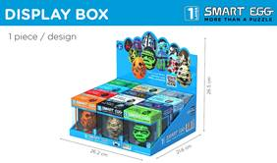  Smart Egg  Art & Smart Egg Kft (Hungary) | 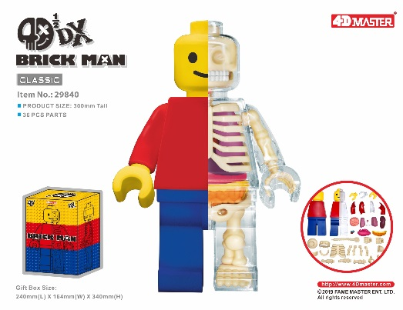  4D ½ DX Brickman (Classic)  Fame Master Enterprise Limited (Hong Kong)
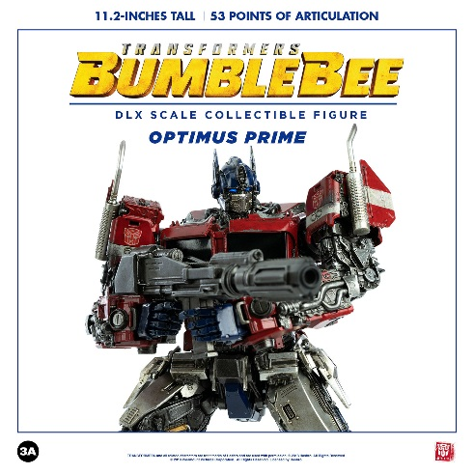  Transformers Bumblebee – DLX Optimus Prime Threezero (HK) Ltd (Hong Kong) | 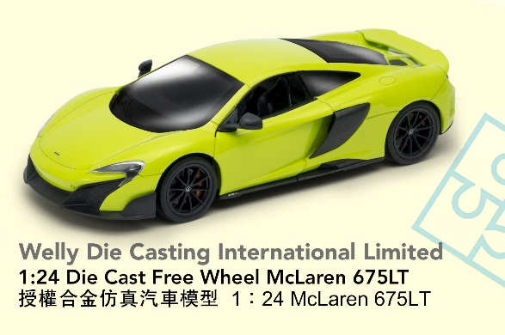  1:24 Die Cast Free Wheel McLaren 675LT  Welly Die Casting International Limited (Hong Kong)

Media Enquiries
Hong Kong Trade Development Council
Eiki Chan Email: eiki.yy.chan@hktdc.org Tel: (852) 2240 4308

About the HKTDC
The Hong Kong Trade Development Council (HKTDC) is a statutory body established in 1966 to promote, assist and develop Hong Kong's trade. With 50 offices globally, including 13 in Mainland China, the HKTDC promotes Hong Kong as a two-way global investment and business hub. The HKTDC organises international exhibitions, conferences and business missions to create business opportunities for companies, particularly small and medium-sized enterprises (SMEs), in the mainland and international markets. The HKTDC also provides up-to-date market insights and product information via trade publications, research reports and digital news channels. For more information, please visit: www.hktdc.com/aboutus. Follow us on Twitter @hktdc LinkedIn

